Class test: Transportation of substances in animals and plants. F.M.- 15
- Read the case study and answer the following questions:

Malti is a 12-year-old student who loves playing soccer. One day, during a particularly intense game, she feels dizzy and out of breath. Concerned, her coach takes her to the school nurse, who notices that Malti’s heart is beating irregularly. The nurse decides to refer Malti to a doctor for further examination.At the doctor's office, Malti undergoes several tests including an electrocardiogram (ECG) and an echocardiogram. The results show that Malti has a condition called "tachycardia," which means her heart is beating faster than normal.The doctor explains the process of blood circulation through the heart and prescribes medication to help regulate Malti’s heart rate and advises her to make some lifestyle changes. She needs to avoid very strenuous activities and focus on moderate exercise. Malti also learns about the importance of a balanced diet and regular check-ups to monitor her heart health.

- Describe the journey of blood through the heart. Include the names of the chambers involved and the direction of blood flow. (2)
- Why is it important for Malti to make lifestyle adjustments and have regular check-ups? (1)
- What tests did Malti undergo to diagnose her condition? (1)
- What condition was Malti diagnosed with, and what does it mean? (1)

2. Assertion (A): Root hairs increase the surface area for water absorption in plants.
Reason (R): Root hairs are a part of the xylem tissue.

A) Both A and R are true, and R is the correct explanation for A.
B) Both A and R are true, but R is not the correct explanation for A.
C) A is true, but R is false.
D) A is false, but R is true.

3. Which part of the human circulatory system is responsible for the exchange of gases (oxygen and carbon dioxide) with tissues?

A) Arteries
B) Veins
C) Capillaries
D) Heart

4. In animals, which blood vessel carries oxygenated blood from the lungs to the heart?

A) Pulmonary artery
B) Aorta
C) Pulmonary vein
D) Vena cava

5. Which type of blood vessel has valves to prevent backflow of blood?

A) Arteries
B) Capillaries
C) Veins
D) Arterioles

6. Label the following parts : (4)
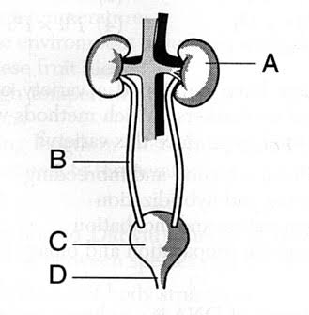

7. Why do you think transportation of substances is required in plants and animals? (2)

